**Minor Project Report**

**on**

**DocEase**

**In partial fulfillment for the award of the degree**

**Of**

**BACHELOR OF COMPUTER APPLICATION**

**[B.C.A]**

**Year 2023-2024**

**SUBMITTED BY:**     **GUIDED BY:**

**Utsav N. Dudhat**     **Prof. Riddhi Joshi**

**BCA-5th SEMESTER**

**Submitted to:**



**SHRI SHAMBHUBHAI V. PATEL COLLEGE OF**

**COMPUTER SCIENCE & BUSINESS MANAGEMENT**

Affiliated to

**Veer Narmad South Gujarat University**

**INDEX**

|  |  |
| --- | --- |
| **Chapter** | **Page No.** |
| 1. **Introduction**   1.1 Project Description  1.2 Project Profile | 3  4 |
| 1. **Objectives** | 5 - 6 |
| 1. **System Flow Diagram** | 7 - 8 |
| 1. **DFD / UML Diagram** | 9 - 11 |
| 1. **ER Diagram** | 12 |
| 1. **Database Design** | 13 - 16 |
| 1. **System Design** | 17 - 25 |
| 1. **References** | 26 |

1. **Introduction**

**1.1 Project Description**

* DocEase Application is a system designed primarily for use easy online doctor appointment management application.
* This system is fully responsive or mobile friendly and have a good-looking user interface.
* DocEase Application have contained two panels:
* Doctor Panel
* Patient Panel
* **Doctor Panel:**
* Doctor can register itself with an appropriate field.
* Doctor can login with valid credentials.
* Doctor can update his / her profile.
* Doctor can view his / her appointments with his / her patients.
* Doctor can confirm the appointments.
* **Patient Panel:**
* Patient can register itself with an appropriate field.
* Doctor can login with valid credentials.
* Patient can update his / her profile.
* Patient can view all doctors which are register at doctor panel.
* Patient can appoint doctor easily.
* Patient can view his / her appointments.

**1.2 Project Profile**

|  |  |
| --- | --- |
| **DocEase** | |
| Project Title | DocEase |
| Frontend | XML , Java |
| Backend | Firebase |
| Supported OS | Android |
| IDE | Android Studio |
| Browsers | Google Chrome, Brave |
| Documentation tool | MS Word |
| Internal Guide | Prof. Riddhi Joshi (HOD) |
| Submitted to | Prof. Riddhi Joshi (HOD) |

1. **Objectives**

* **Appointment Scheduling:**

Enable patients to easily schedule, reschedule, or cancel appointments with healthcare providers at their convenience. This reduces the need for phone calls and streamlines the appointment process.

* **Improved Access:**

Ensure patients have easy access to a variety of healthcare providers, including primary care physicians, specialists, and allied health professionals. This can be especially helpful in areas with limited healthcare resources.

* **Real-time Availability:**

Display real-time availability of healthcare providers, allowing patients to choose appointments based on their preferred time slots and provider availability.

* **Reduced Wait Times:**

Minimize the time patients spend waiting in the clinic by providing estimated wait times and allowing them to check in online or virtually.

* **Patient Information Management:**

Allow patients to securely store and manage their medical records, including past appointments, test results, and medications, within the app for easy access by healthcare providers.

**Start to End Process:**

1. Collecting information for system (Requirement Gathering and Analysis).
2. Preparing the design of the system through information.
3. Creating table definition and implementation.
4. Integration of Front-end and Back-end.
5. Custom Functions & Validations.
6. Making responsive design.
7. Testing.
8. Debugging and code optimization.
9. **System Flow Diagram**

* **Doctor Process Flow Diagram:**

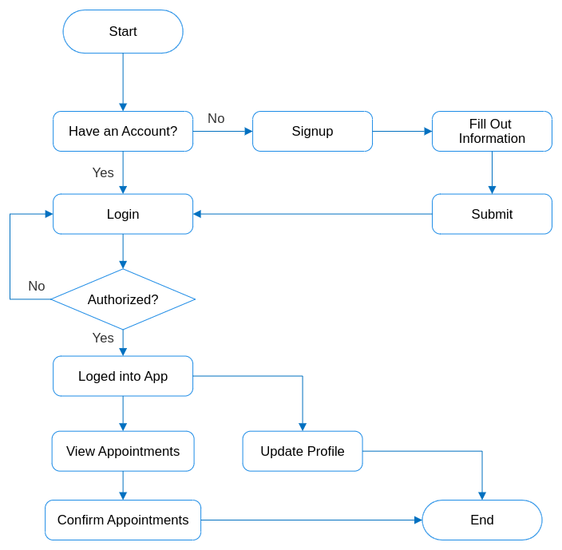

* **Patient Process Flow Diagram:**

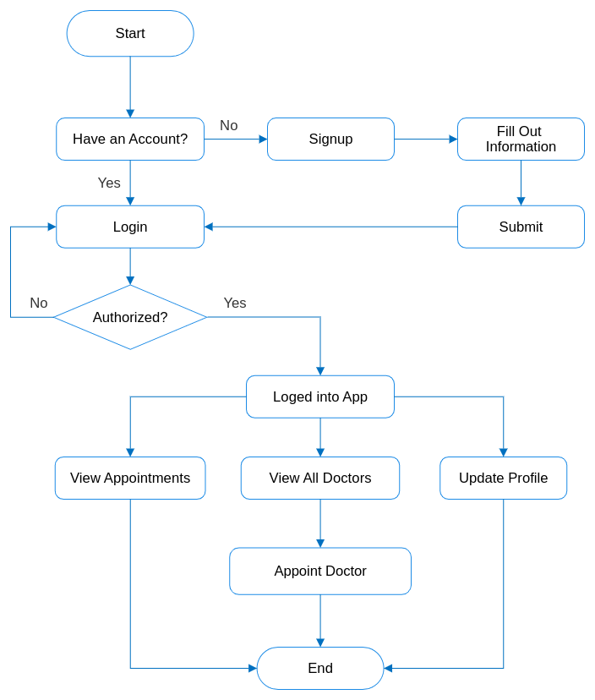

1. **DFD / UML Diagram**

* **0 Level Diagram (Context Diagram):**

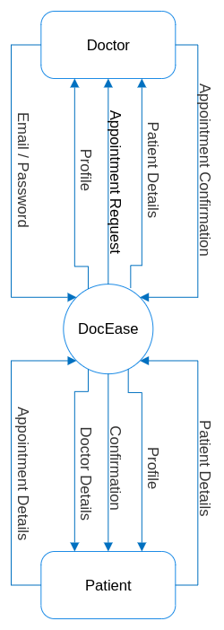

* **1st Level Doctor Diagram:**

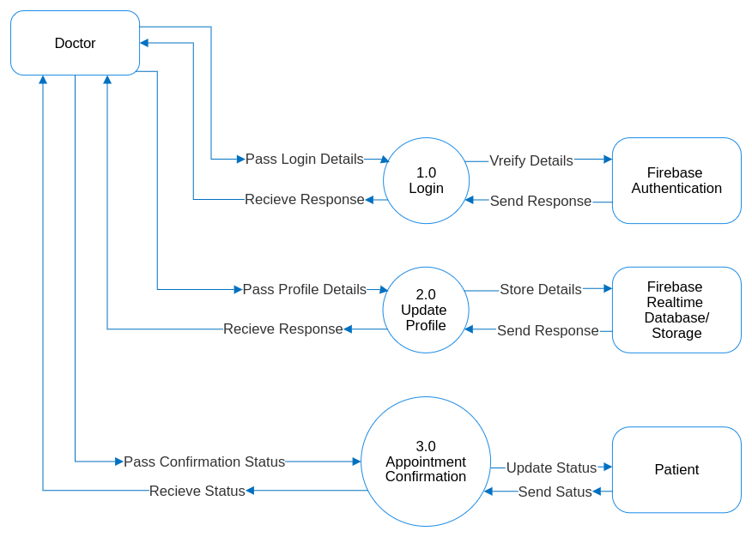

* **1st Level Patient Diagram:**

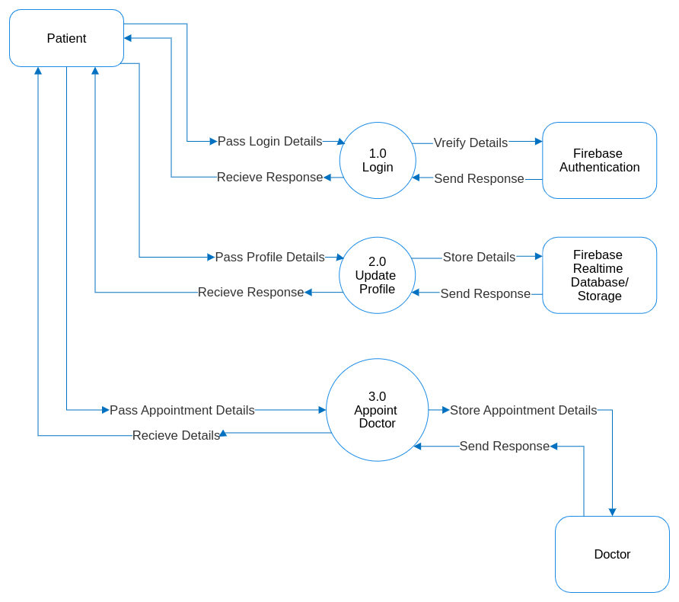

1. **ER Diagram**

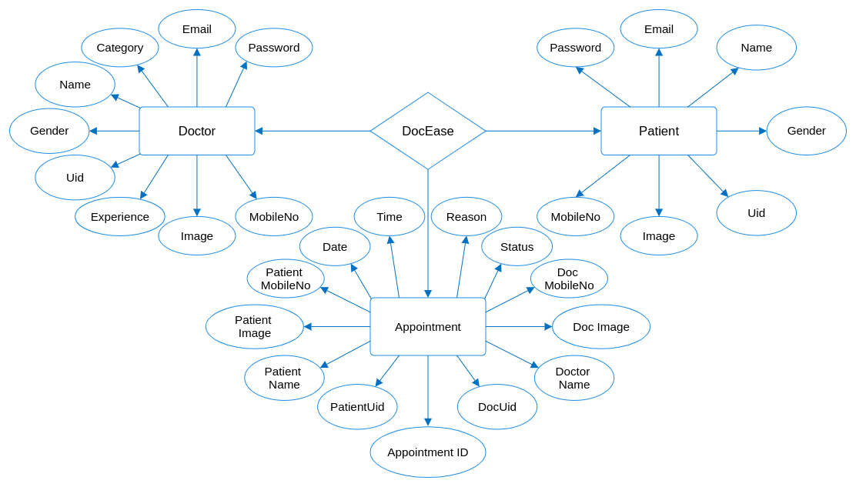

1. **Database Design**

* **Firebase Authentication:**
* Email ID
* Password
* Uid
* **Firebase Realtime Database:**

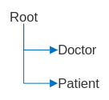

* **Doctor Side database:**

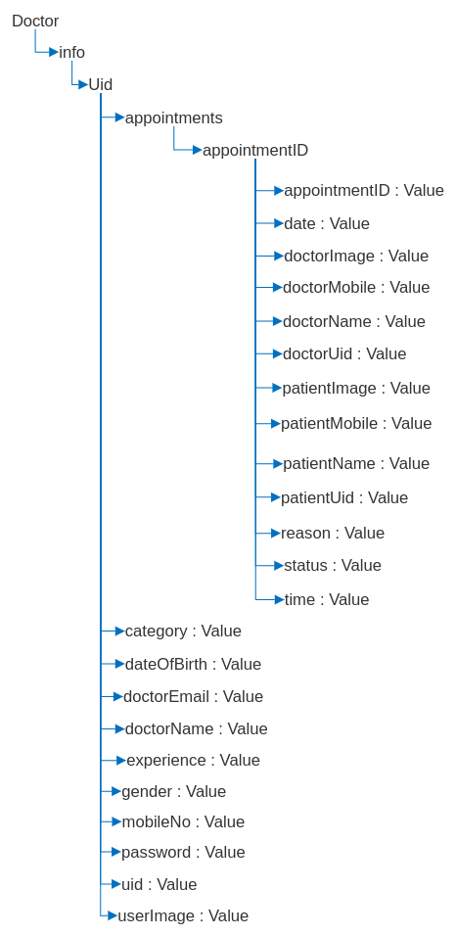

* **Patient Side database:**

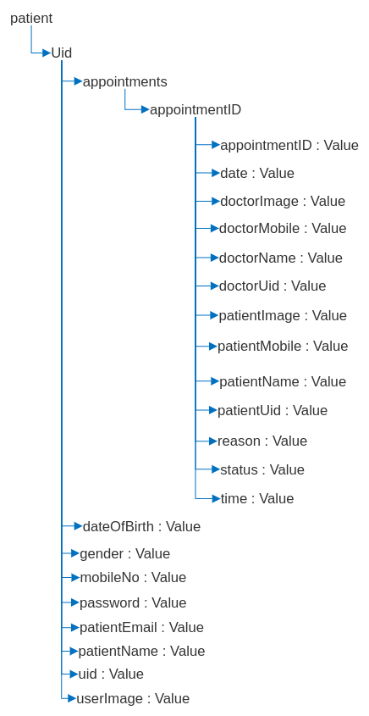

* **Firebase Storage:**
* Doctor/
* Patient/
* Doctor Folder contains profile photos of doctors.
* Patient Folder contains profile photos of patients.
* **Connection Between Authentication, Database and Storage:**

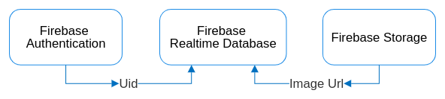

1. **System Design**

|  |  |  |
| --- | --- | --- |
| * **Splash Screen:** | * **Onboarding Screen:** | * **Role Screen:** |
|  |  |  |

* **Patient Side App:**

|  |  |
| --- | --- |
| * **Login Screen:** | * **Registration Screen:** |
|  |  |

|  |  |
| --- | --- |
| * **Home Screen:** | * **All Doctor Screen:** |
|  |  |

|  |  |
| --- | --- |
| * **Book Appointment Screen:** | * **All Appointments Screen:** |
|  |  |

|  |  |
| --- | --- |
| * **Profile Screen:** | * **Update Profile Screen:** |
|  |  |

* **Doctor Side App:**

|  |  |
| --- | --- |
| * **Login Screen:** | * **Registration Screen:** |
|  |  |

|  |  |
| --- | --- |
| * **Home Screen:** | * **Pending Appointment Screen:** |
|  |  |

|  |  |
| --- | --- |
| * **Confirmed Appointment Screen:** | * **Profile Screen:** |
|  |  |

|  |  |
| --- | --- |
| * **Update Profile Screen:** | * **About Us Screen:** |
|  |  |

1. **References**

* [**https://firebase.google.com/docs**](https://firebase.google.com/docs)
* [**https://developer.android.com/docs**](https://developer.android.com/docs)
* [**https://github.com/**](https://github.com/)
* [**https://stackoverflow.com/**](https://stackoverflow.com/)
* [**https://www.behance.net/**](https://www.behance.net/)